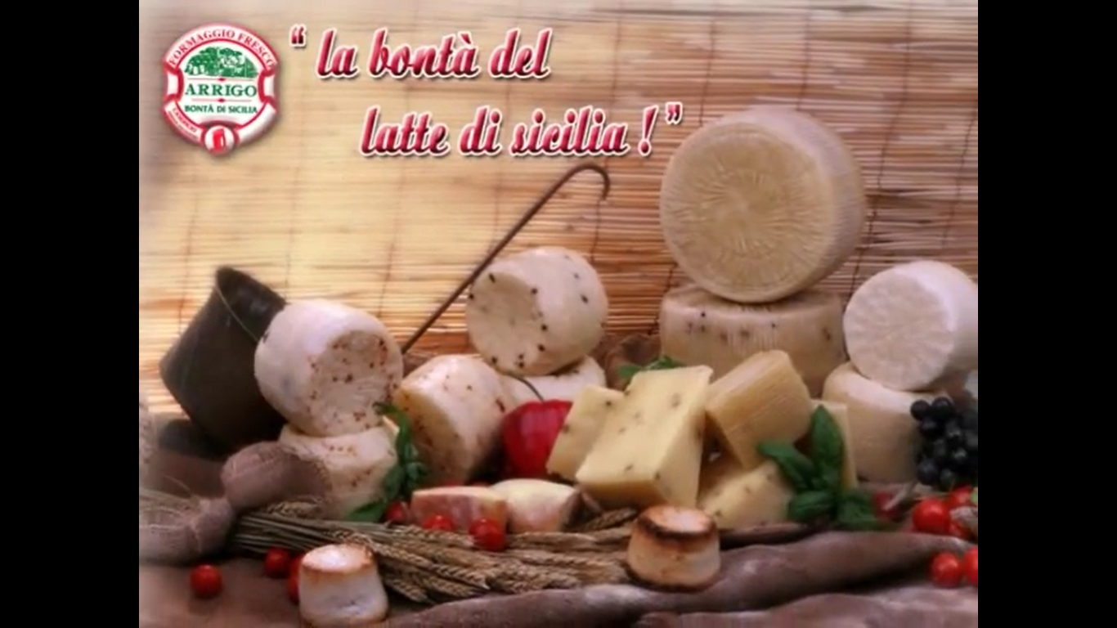

***AZIENDA AGRICOLA CASEARIA SALVATORE ARRIGO***

***Farming of sheep and goats, CAMPOBELLO DI LICATA***

*Azienda Agricola Casearia Salvatore Arrigo is a sheep and goat farm in Campobello Di Licata. This private company was founded in 1985 and employs 4 people.*

Individual training plan on recruitment, as an apprentice.

Search for a dairy company a support worker. The apprentice will be placed in support of the cheese maker, carrying out operational duties within the dairy for the preparation of cheese and the cleaning of work tools.

Request previous experience gained in the same job, availability for holidays, physical training, fond of animals, desire to learn, working in group.

**Employer name:**

**AZIENDA AGRICOLA CASEARIA SALVATORE ARRIGO**

**Legal Form**

**INDIVIDUAL BUSINESS**

**Registered office**:

**C.DA SERRA DI MENDOLA, SN, 92023 CAMPOBELLO DI LICATA Agrigento**

**REA Code**

**AG - 139266AG - 139266.**

**Activity**

**FARMING OF SHEEP AND GOATS**

**B. Apprentice information**

Name _________________________________________________________________

Surname _________________________________________________________________

Security Social Number _______________________________________________________

Date and place of birth _____________________________________________________________

Address _______________________________________________________________________

Telephone number _______________________________________________________

email_______________________________________________________

Nationality _____________________________________________________________________

**INCLUDE YOUR UPDATED EUROPASS**

Apprentice signature

__________________________